1. **Showing Baby Names M vs F - Horizontal % of Total Bar with centered 0 point**

### Build a chart showing the top five and bottom five sales by customer

### First create Calculated field

IF RANK(SUM([Sales]), 'desc') <= 5

THEN 'Top 5'

ELSEIF RANK(SUM([Sales]), 'asc') <= 5

THEN 'Bottom 5'

ELSE NULL

END

Next, we'll drag the new field to the **Filters** shelf and select 'Top 5' and 'Bottom 5' only. Drag the field to the **Rows** shelf too. Now, let's add the Customer Name to the **Rows** shelf and the Sales field over the **Text** label. You're done!

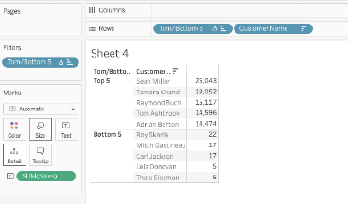

### Find the state with the lowest profit ratio

First, we'll create a calculated field and enter the following formula:

SUM([Sales]) / SUM([Profit])

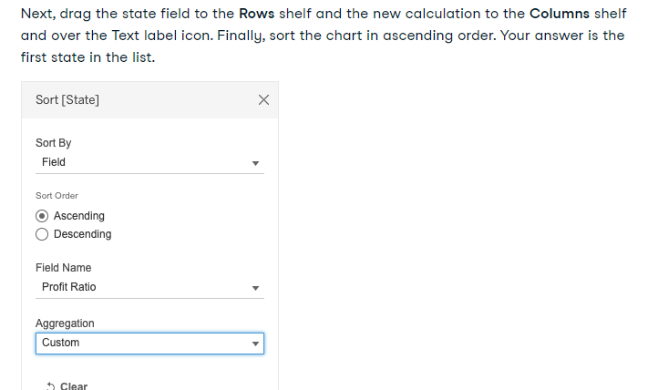

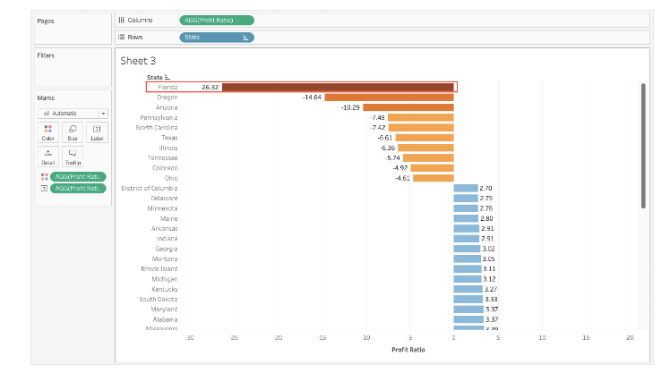

1. . Find the top 10 Product Names by Sales within each region. Which product is ranked #2 in both the Central & West regions in 2011?
2. Find the customer with the lowest overall profit. What is his/her profit ratio?

Ans : The answer to this question can be found by looking at profits by customer and sort ascending by profit. Once you identify your customer contributing the least to your profits, add a profit ratio calculation (Sum([Profit])/Sum([Sales])) to the label or tooltip.

1. . What was the Moving Average of Sales in June of 2012, including six months prior and six months after?

Ans 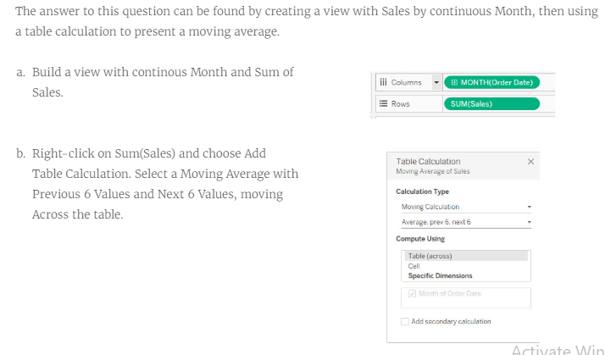

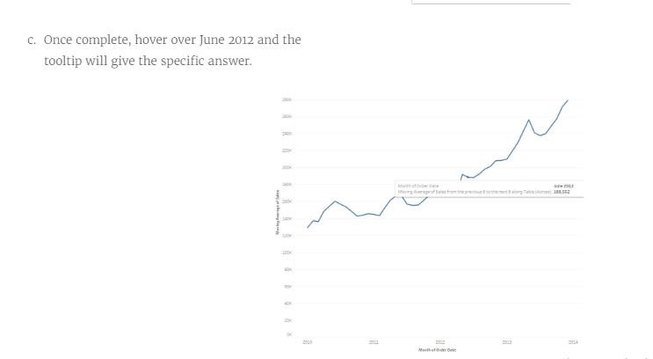

1. For boys born between 2000 and 2012, the most common first letter for the top name by state was:

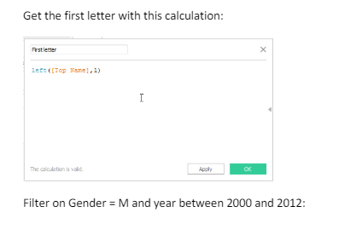

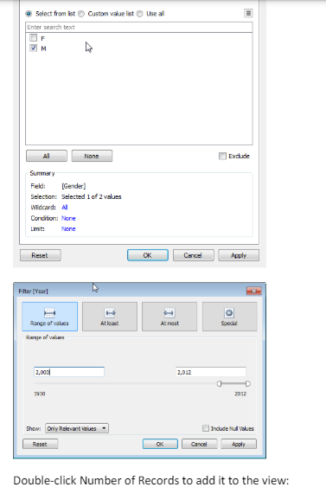

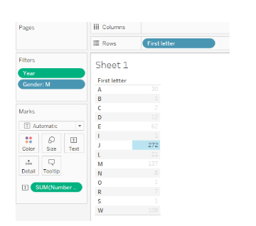

1. Find the total sales value for all product categories for customers who ordered office furniture.
2. Build a Dashboard There should be four sheets: 1.Profit Ratio by Geography 2.Sales by Category

3.Key Performance Indicators 4.Profit Ratio by City

10. Based on Ship Mode, Which customer segment has the highest Average Sales.